MSTR Issue :

Issue 1:Count of the ‘#Total Devices metric data is not matched with MSD and Redshift.

SELECT a.sys_class_name,

Count(1) as CNT

FROM png_mdsdb.cmdb_ci_final a

Where a.sys_class_name IN ('cmdb_ci_hardware','cmdb_ci_storage_device','cmdb_ci_voice_hardware')

AND a.cdctype<>'D'

group by 1;

redshift :

Select b.sys_class_name_c,count(1)

FROM ldb.f_configuration_item a

JOIN ldb.d_configuration_item b ON a.configuration_item_key=b.row_key

WHERE b.sys_class_name_c IN ('cmdb_ci_hardware','cmdb_ci_storage_device','cmdb_ci_voice_hardware')

group by 1;

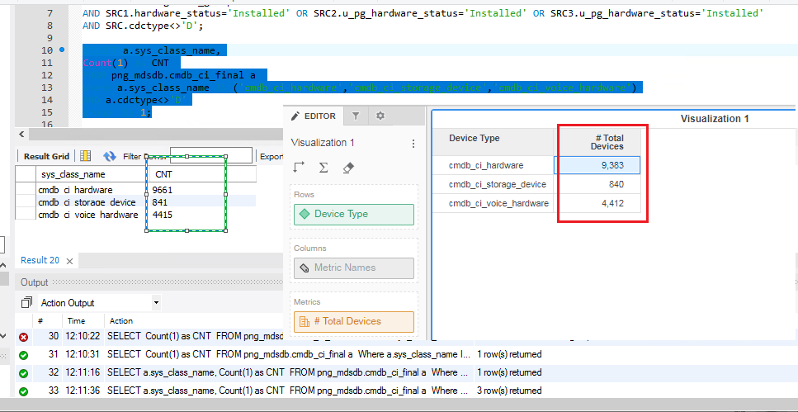

Issue 2: Noticed UNKNOW and UNSPECIFIED in the Hardware Status with 0 metric data :

UNKNOWN should not be displayed and Unspecified should display the respective value.

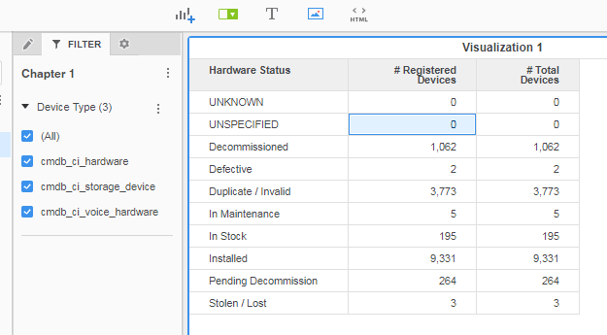

Issue 3: ‘# Active Devices’ metric data is not matching with MDS:

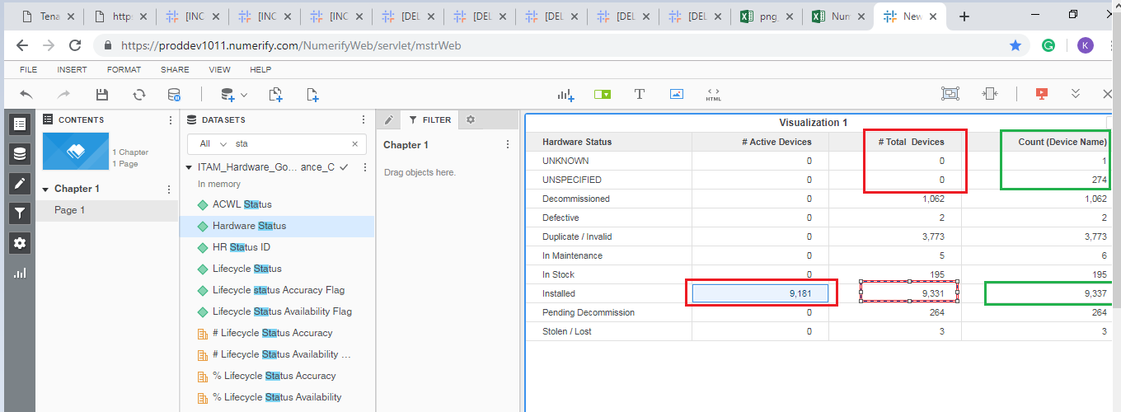

Issue 4: Hardware is having ‘UNKNOWN’

SELECT SRC.name,SRC.sys_class_name,SRC1.hardware_status

FROM png_mdsdb.cmdb_ci_final SRC

LEFT JOIN png_mdsdb.cmdb_ci_hardware_final SRC1 ON SRC.sys_id=SRC1.sys_id AND SRC.sourceinstance=SRC1.sourceinstance

LEFT JOIN png_mdsdb.cmdb_ci_storage_device_final SRC2 ON SRC.sys_id=SRC2.sys_id AND SRC.sourceinstance=SRC2.sourceinstance

LEFT JOIN png_mdsdb.cmdb_ci_voice_hardware_final SRC3 ON SRC.sys_id=SRC2.sys_id AND SRC.sourceinstance=SRC2.sourceinstance

WHERE SRC.name='mp181hq8-w10'

AND SRC.cdctype<>'D';

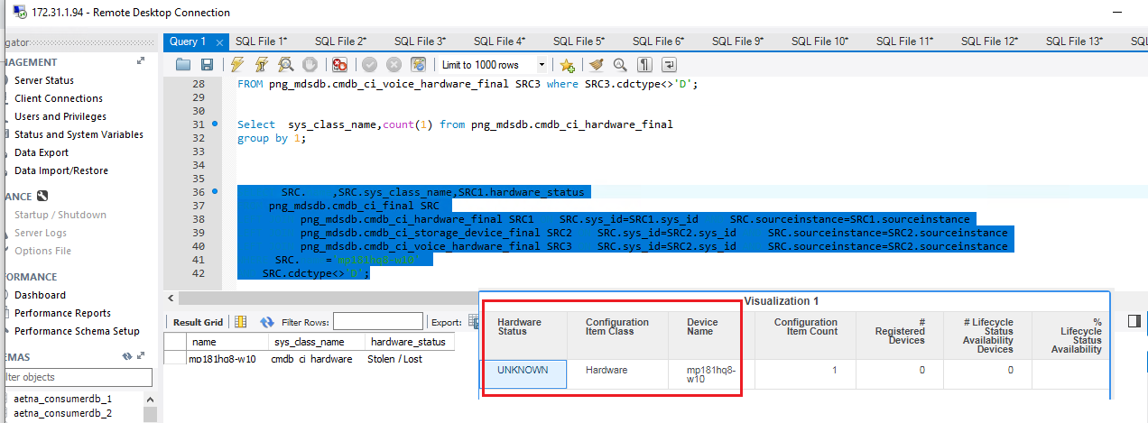

Issue 5: count of registered devices data is not matched

SELECT

Count(1) as CNT

FROM png_mdsdb.cmdb_ci_final SRC

LEFT JOIN png_mdsdb.cmdb_ci_hardware_final SRC1 ON SRC.sys_id=SRC1.sys_id AND SRC.sourceinstance=SRC1.sourceinstance

LEFT JOIN png_mdsdb.cmdb_ci_storage_device_final SRC2 ON SRC.sys_id=SRC2.sys_id AND SRC.sourceinstance=SRC2.sourceinstance

LEFT JOIN png_mdsdb.cmdb_ci_voice_hardware_final SRC3 ON SRC.sys_id=SRC2.sys_id AND SRC.sourceinstance=SRC2.sourceinstance

WHERE SRC.assignment_group iS NOT NULL

AND SRC.cdctype<>'D';

Issue 6: ‘# Managed Devices’ metric is displaying 0

Clarification needed, as the Metric is resulting 0,(is it tenable source)?

Resolved

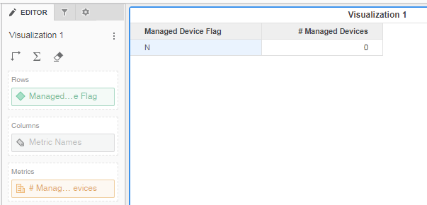

Issue 7: Organization Manager Details and Owned By Details are displaying the ID from and not mentioned in Design Document

Resolved

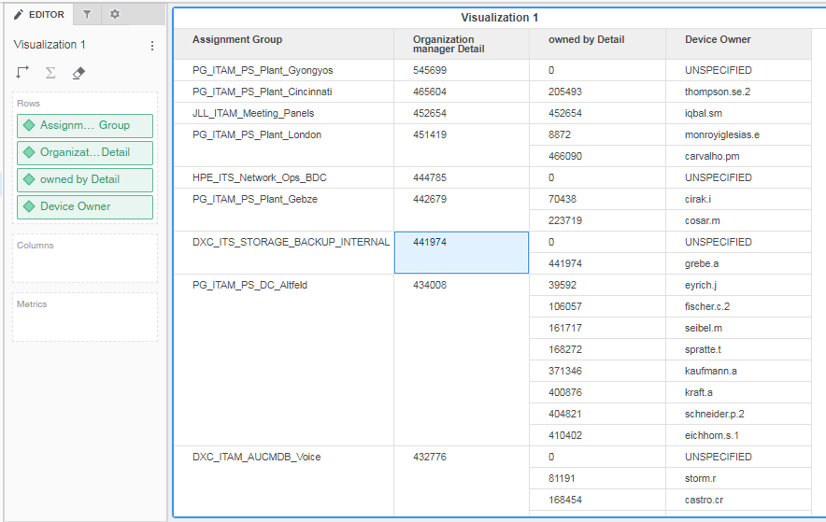

Issue 8:

Registered count and Active device count is not matched with source query.

Issue 9:

SELECT LKP.employee_type_c,

Count(1) as CNT

FROM png_mdsdb.cmdb_ci_final SRC

LEFT JOIN png_mdwdb.f_configuration_item TRGT ON SRC.sys_id=TRGT.row_id AND SRC.sourceinstance=TRGT.source_id

LEFT JOIN png_mdwdb.d_internal_contact LKP ON CONCAT('INTERNAL_CONTACT~',SRC.owned_by)=LKP.row_id AND SRC.sourceinstance=LKP.source_id

WHERE SRC.cdctype<>'D'

group by 1;

redshift :

SELECT b.employee_type_c,

Count(a.configuration_item_key) as Row_Count

FROM ldb.f_configuration_item a

JOIN ldb.d_configuration_item c ON a.configuration_item_key=c.row_key

JOIN ldb.d_owned_by b ON a.owned_by_key=b.row_key

WHERE a.soft_deleted_flag='N'

AND c.hardware_applicable_flag_c='Y'

group by 1;

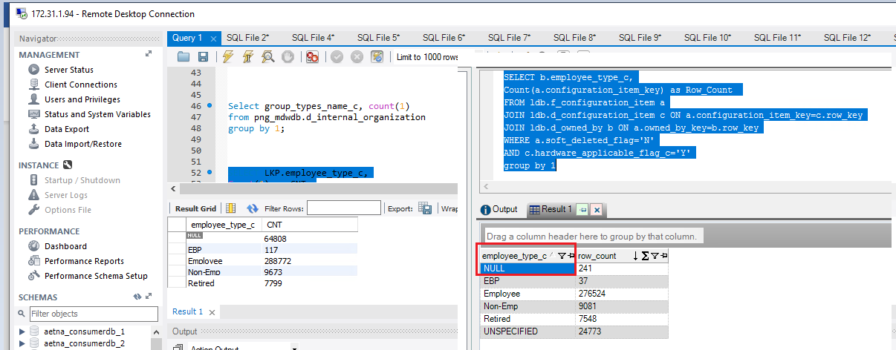

Issue 10:

‘Area’ is displayed as NULL

SELECT d.area_c,

Count(a.configuration_item_key) as Row_Count

FROM ldb.f_configuration_item a

JOIN ldb.d_configuration_item c ON a.configuration_item_key=c.row_key

JOIN ldb.d_owned_by b ON a.owned_by_key=b.row_key

JOIN ldb.d_location d ON c.location_key=d.row_key

WHERE a.soft_deleted_flag='N'

AND c.hardware_applicable_flag_c='Y'

group by 1;

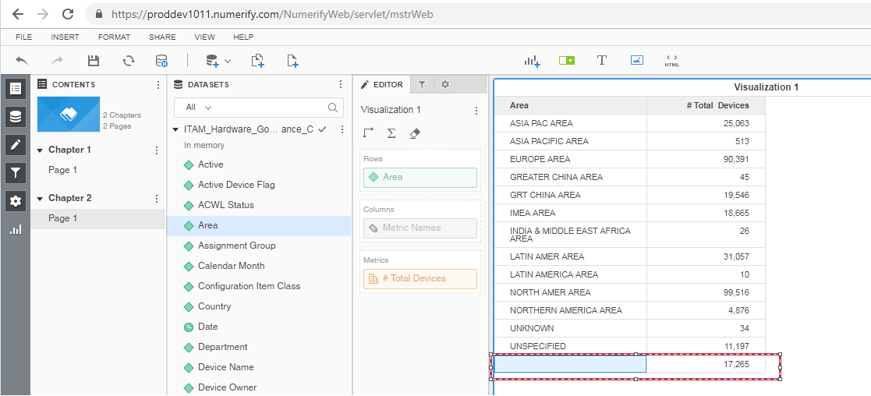

Issue 11: Department is completely null

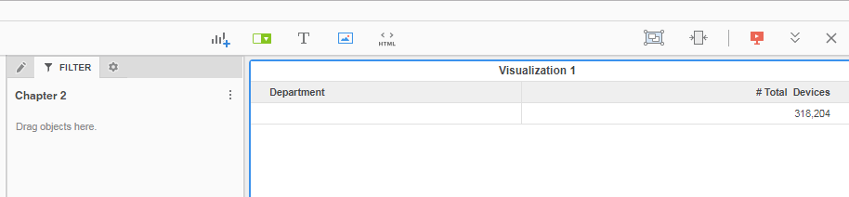

Clarification : is the hardware Status (‘Duplicate/Invalid’ ) is not included in the Registration Device clarification?

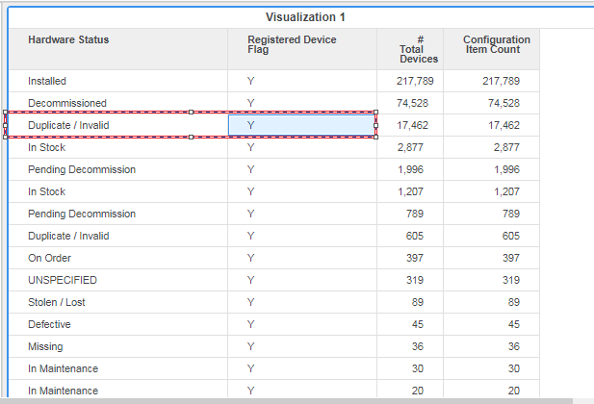

Not an issues : Life cycle Status as : Leverage/Optimize or ‘Design/Build’

# Active Devices Metrics is not displaying the accurate data , it should be same as of # Registered devices when filter is applied.

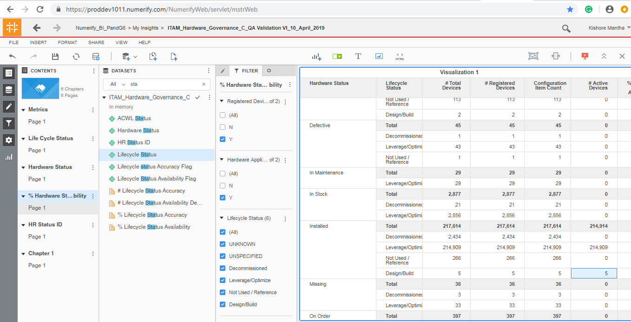

Issues on 18-April-2019:

Issue 12:’ pg_yn_network_connected_flag_c’ flag has been failed for 9 records :

SELECT COALESCE(SRC1.u_pg_yn_network_connected,'UNSPECIFIED'),TRGT.pg_yn_network_connected_flag_c,

Count(1) as CNT

FROM png_mdsdb.cmdb_ci_final SRC

LEFT JOIN png_mdsdb.cmdb_ci_hardware_final SRC1 ON SRC.sys_id=SRC1.sys_id AND SRC.sourceinstance=SRC1.sourceinstance AND SRC1.cdctype<>'D'

LEFT JOIN png_mdwdb.d_configuration_item TRGT ON SRC.sys_id=TRGT.row_id AND SRC.sourceinstance=TRGT.source_id

WHERE COALESCE(SRC1.u_pg_yn_network_connected,'UNSPECIFIED')<>TRGT.pg_yn_network_connected_flag_c

AND SRC.cdctype<>'D'

group by 1;

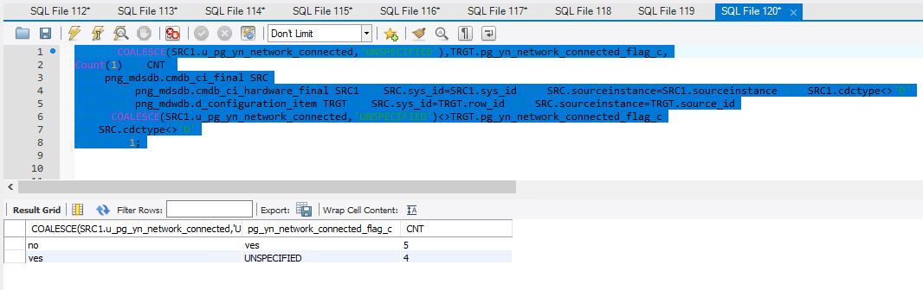

Issue 13: last_discovered query has been filed :

SELECT Count(1) as CNT

FROM png_mdsdb.cmdb_ci_final SRC

LEFT JOIN png_mdwdb.d_configuration_item TRGT ON SRC.sys_id=TRGT.row_id AND SRC.sourceinstance=TRGT.source_id

WHERE CONVERT_TZ(SRC.last_discovered,'GMT','America/New_York')<>TRGT.last_discovered

AND SRC.cdctype<>'D';

